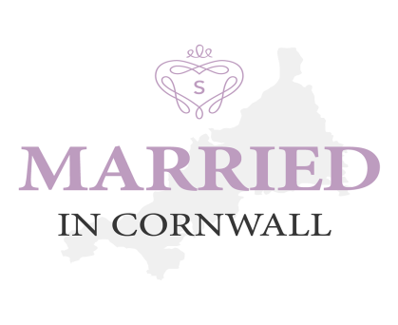
A Cornish Wedding Directory
www.marriedincornwall.co.uk

Hello and Welcome!
Thank you so much for requesting to sign up to our new amazing directory. We hope it can be a great place for Brides and Grooms to get some great contacts for planning their big days. And ultimately a great way for you to get new business to you!
For a small monthly fee you can be assured you business will be easily accessible, with pictures showing your amazing talents and clickable links direct to your websites and social media pages.
What we offer..
We will use Married In Cornwall as a lovely little add on to Simply Weddings. We will share the site over Facebook and Twitter and aim to get every couple planning a wedding to use Married in Cornwall as a great research tool.
We have a Facebook page set up so if you need to post a special offer or deal you can list it there. It is on a pre approved post system and only people listed with Married in Cornwall can post.
What we promise..
We will advertise Married in Cornwall at all opportunities, therefore advertising your businesses to. The listings are set out in the packages (free, Silver, Gold, Platinum), they are at first listed as a first come first served basis, however, once a month we will moving the listings in order within their groups. So if you are the last to sign up in the platinum package, next month you will be moved to the top, and will then proceed down the list every month. We feel that this is fair, everyone gets moved around so you will all get seen. Although I’m sure with all your wonderful pictures the brides and grooms will be scrolling through you all!!
What you must do..
You must check when your listing is live that all the information and links are correct.
Payment information will be at the bottom of this document.
By agreeing to list your business, you are agreeing to pay a monthly fee via standing order (until the direct debit scheme is introduced). Payments are due on the 7th of each month; failure to pay will result in your listing being removed.
This is monthly payment scheme; we cannot take annual subscription to this service.
If you would like to cancel or downgrade your listing we ask for 1 months notice. We will confirm the removal date after you have notified us.
If you would like a toggle for your site to say you are member please let us know.
A Cornish Wedding Directory
www.marriedincornwall.co.uk
Subscription Application
Please complete the following in accordance to which package you would like. You can either fill in the form below or email direct to info@marriedincornwall.co.uk.
Silver Package, 99p per month: Business Name and Phone Number with a clickable link to your website
Gold Package, £1.99 per month: As above but also include your Logo
Platinum Package, £4.99 per month: All of the above but also include 4 pictures, 2 social media links and a small bio about your business. As a platinum member you will qualify for 10% off any Simply Weddings Wedding Fayre bookings.
Business Name:
Business Contact Name:
Business Telephone:
Email:
Website:
Social Media Link 1:
Social Media Link 2:
Bio:

Please don’t forget to attach your Logo and 4 pictures showcasing your business.
Thank you From The Married in Cornwall Team
Payments – We will send you the Direct debit information after your ad has gone live and you have approved the content.
Married in Cornwall is partnered with Simply Weddings. www.simplyweddingscornwall.co.uk 07985 187825

